|  |
| --- |
| Serial No: |
| **Sessional I** |
| **Total Time: 1 Hour** |
| **Total Marks: 50** |
| ________________  Signature of Invigilator |

|  |
| --- |
| **CS 301 & Theory of Automata** |
| Monday, September 23, 2013 |
| **Course Instructor** |
| Dr. Waseem Shahzad and Ms. Mehreen Alam |

|  |
| --- |
| **______________________________ _________ ______ _____________________**  Student NameRoll No Section Signature |

## DO NOT OPEN THE QUESTION BOOK OR START UNTIL INSTRUCTED.

**Instructions:**

1. Attempt on question paper. Attempt all of them. Read the question carefully, understand the question, and then attempt it.
2. No additional sheet will be provided for rough work. Use the back of the last page for rough work.
3. If you need more space write on the back side of the paper and clearly mark question and part number etc.
4. After asked to commence the exam, please verify that you have seven (7) different printed pages including this title page. There are total of 5 questions.
5. Use permanent ink pens only. Any part done using soft pencil will not be marked and cannot be claimed for rechecking.

|  |  |  |  |  |  |  |
| --- | --- | --- | --- | --- | --- | --- |
|  | Q-1 | Q-2 | Q-3 | Q-4 | Q-5 | **Total** |
| **Marks Obtained** |  |  |  |  |  |  |
| **Total**  **Marks** | 10 | 10 | 10 | 10 | 10 | **50** |

**Vetted By: _____________________________ Vetter Signature: _____________________**

**Question 1:- Marks 5+5.**

a. Give recursive definition of the language Powers of Two.

b. Give recursive definition of the language, defined over the alphabet *{a, b},* the language EVENSTRING, i.e. of all words of even length.

**Question 2:- Marks 5+5.**

Draw the DFA accepting the following languages:

a. ***(ab + bb)\****

b. ***b* + b*a(ba)\****

**Question 3:- Marks 5+5.**

Determine the regular expression of the language accepted by following FAs.

a.

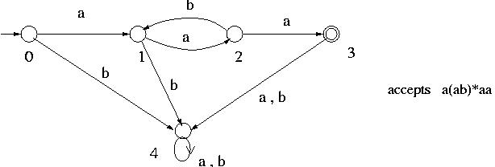

b.

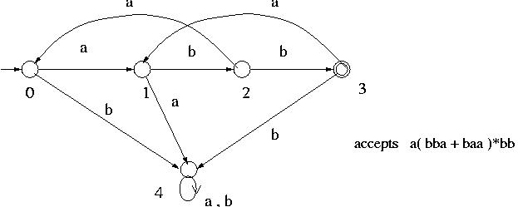

**Question 4:- Marks 5+5.**

Consider the language over the alphabet = { a,b }

a. Construct a regular expression in which the total number of ‘b’ is divisible by 4 no matter how they are distributed and ‘a’ are only found in clumps that is divisible by 3.

e.g. - b b a a a b a a a a a a a a a b

- a a a a a a b b b b a a a b a a a b b b

b. All strings with even number of b’s

**Question 5:- Marks 5+5.**

Convert the following TGs to REs. Do show the necessary steps.

a.

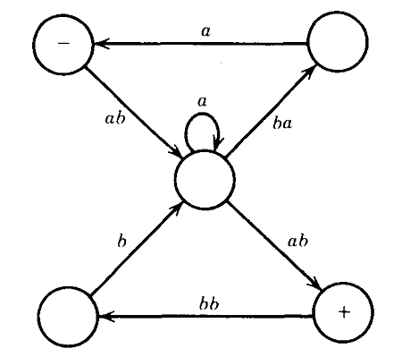

b.

